**Arduino with PIR Motion Sensor**

In this project you’re going to create a simple circuit with an Arduino and PIR motion sensor that can detect movement. An LED will light up when movement is detected.

**Watch the video below to see how it works**

**Introducing the PIR Motion Sensor**

The PIR motion sensor is ideal to detect movement. PIR stand for “Passive Infrared”. Basically, the PIR motion sensor measures infrared light from objects in its field of view.

So, it can detect motion based on changes in infrared light in the environment. It is ideal to detect if a human has moved in or out of the sensor range.

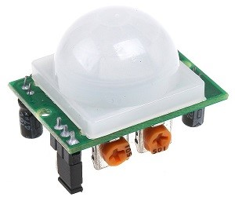

The sensor in the figure above has two built-in potentiometers to adjust the delay time (the potentiometer at the left) and the sensitivity (the potentiometer at the right).

**Pinout**

Wiring the PIR motion sensor to an Arduino is pretty straightforward – the sensor has only 3 pins.

* GND – connect to ground
* OUT – connect to an Arduino digital pin
* 5V – connect to 5V

**Parts required**

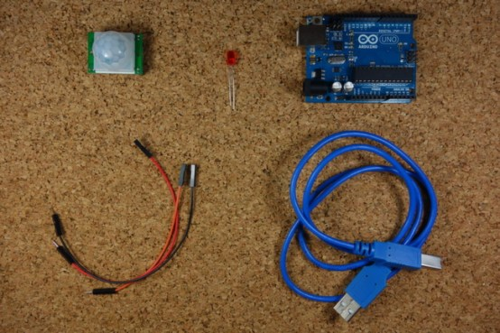

Here’s the required parts for this project

* [1x PIR Motion Sensor (HC-SR501)](https://makeradvisor.com/tools/pir-motion-sensor-hc-sr501/)
* [Arduino UNO](https://makeradvisor.com/tools/compatible-arduino-uno-r3-board/) – read [Best Arduino Starter Kits](https://makeradvisor.com/best-arduino-starter-kits/)
* [1x LED](https://makeradvisor.com/tools/3mm-5mm-leds-kit-storage-box/)
* [Jumper Cables](https://makeradvisor.com/tools/jumper-wires-kit-120-pieces/)

You can use the preceding links or go directly to [MakerAdvisor.com/tools](https://makeradvisor.com/tools/?utm_source=rnt&utm_medium=post&utm_campaign=post) to find all the parts for your projects at the best price!

[](https://makeradvisor.com/tools/?utm_source=rnt&utm_medium=post&utm_campaign=post)

**Schematics**

Assemble all the parts by following the schematics below.

[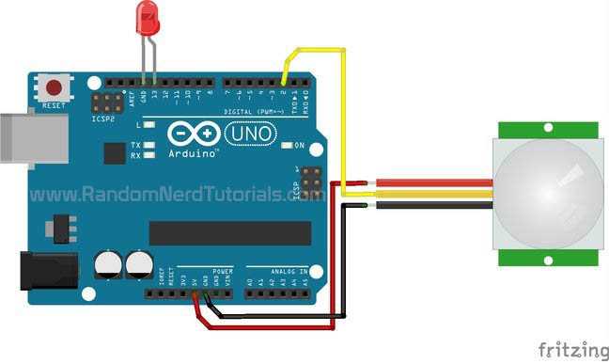](https://i0.wp.com/randomnerdtutorials.com/wp-content/uploads/2014/08/Arduino-with-PIR-motion-sensor-schematics.jpg?quality=100&strip=all&ssl=1)

**Code**

Upload the following code.

/*

Arduino with PIR motion sensor

For complete project details, visit: http://RandomNerdTutorials.com/pirsensor

Modified by Rui Santos based on PIR sensor by Limor Fried

*/

int led = 13; // the pin that the LED is atteched to

int sensor = 2; // the pin that the sensor is atteched to

int state = LOW; // by default, no motion detected

int val = 0; // variable to store the sensor status (value)

void setup() {

pinMode(led, OUTPUT); // initalize LED as an output

pinMode(sensor, INPUT); // initialize sensor as an input

Serial.begin(9600); // initialize serial

}

void loop(){

val = digitalRead(sensor); // read sensor value

if (val == HIGH) { // check if the sensor is HIGH

digitalWrite(led, HIGH); // turn LED ON

delay(100); // delay 100 milliseconds

if (state == LOW) {

Serial.println("Motion detected!");

state = HIGH; // update variable state to HIGH

}

}

else {

digitalWrite(led, LOW); // turn LED OFF

delay(200); // delay 200 milliseconds

if (state == HIGH){

Serial.println("Motion stopped!");

state = LOW; // update variable state to LOW

}

}

}

[View raw code](https://github.com/RuiSantosdotme/Random-Nerd-Tutorials/raw/master/Projects/Arduino_with_PIR_motion_sensor.ino)

**Wrapping Up**

This post shows a simple example on how to use the PIR motion sensor with the Arduino. Now, you can use the PIR motion sensor in more advanced projects. For example, you can build a [Night Security Light project](https://randomnerdtutorials.com/build-a-night-security-light-with-arduino/).

If you’re an absolute beginner, and you’re just getting started, we recommend taking a look at our [Free Arduino Mini Course](https://randomnerdtutorials.com/arduino-mini-course/).

Thanks for reading. If you like this post probably you might like our next ones, so please support us by [subscribing our blog](https://randomnerdtutorials.com/download/).